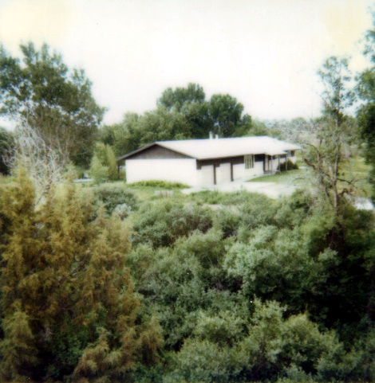**34 – HOME IN FIRTH IDAHO at 447 River Road – June 1984 to June 1986**

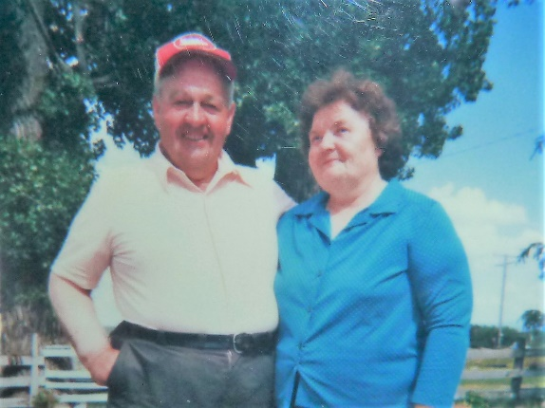 Ken’s younger brother, **Irven** & his family, lived in Goshen, Idaho and wanted Ken to move up and go into business with him in the **A.L. Williams Company**. It is a life insurance company. Since Ken didn’t want to stay with the farm any longer and we didn’t have any other plans, after praying about it, we told him we would try it. Irven knew that it would take some time to build up our clientele so he had some good friends and neighbors, Brent and Rosemary Palmer who needed some remodeling work done on their home. Irven told them about Ken and they agreed to hire him to do their work. Since we didn’t have to worry about selling our home – Ken just gave notice to the Church Farm Committee that he was quitting and they understood why, then we were able to start looking for a home in the area where Irven and Sandy lived. Sandy had found different homes for rent (we couldn’t buy a home as we didn’t have the money for a down payment, and besides we didn’t know for sure if it would work out here in Idaho financially for us.) so we went looking. We got discouraged as we had looked at several homes and either they wanted too much money or it wasn’t something we wanted. Finally, Sandy or Irv mentioned that maybe we should call the bishops in the surrounding stakes and see if they knew of any homes for rent. One bishop told us of a family who were moving to Texas, but their parents were here and they hoped to come back some day so they didn’t want to sell it, just rent it, but they hadn’t put it in the paper yet. We called them and they said we could come and look at it. We fell in love with it at first sight. It was a nice, large home on 5 acres of land down River Road which was close to the Snake River. It was in the farming town of Firth. The lady’s name was Darlene Tew. The family was wonderful and after they showed us the home and yard, we asked them how much they wanted for rent. They said they had been praying about the right family to rent their home as they wanted an LDS family and one with several children, but a family who would love their home and take good care of it. **They said they felt good about us and thought the Lord was answering their prayers to send us to them. We felt the same way as we had been praying about finding a good home for our family.** We found out that his parents owned the land all around and gave him and his brother (Kurt & his wife, Karla) a plot of land to build their homes. **Kurt and Karla** were our neighbors and we lived down in a little valley from the highway. The parents**, Rodney and Noma Tew** lived just across the road. They were all such wonderful people. We fell in love with all of them right away. Rodney and Noma were our second parents. They treated us like their children. They were so good to us.

When we were moving up, I got a terrible headache. Ken’s mother came up with us to help us move in. She always took **Excedrin** as she had headaches frequently. I didn’t have any aspirin or Tylenol so just before we got to Firth, she gave me two Excedrin. By the time we got to the home, I was feeling a little dizzy. I mentioned it to Ken and he helped me into the house and had me lay down on the carpet. I started feeling like I was sinking into a black hole. I found I had no strength to lift any of my limbs, I couldn’t speak and I felt like I was dying. Ken and his mom became really worried and were about to call 911 when suddenly the strength started coming back and I could speak and told them I thought I would be alright now. Soon I was feeling much better. The only thing we can think is that I am highly allergic to Excedrin. I resolved never to take that again.

All the neighbors and ward members were so friendly and kind. While we were moving in, they came to help us, they brought us food and were excited to have us in the ward and neighborhood. Some small towns are not like this. Grantsville had not been this friendly as they didn’t want outsiders moving in. We eventually did fit in and grew to love most of the people in Grantsville, however. At least I did.

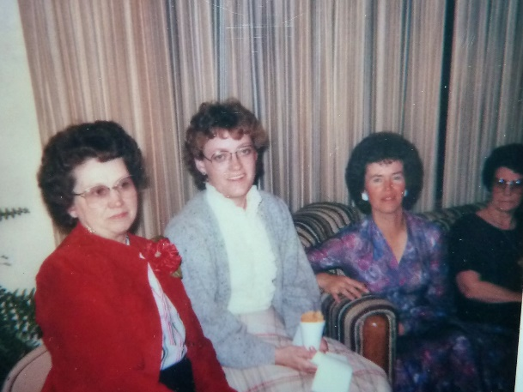**Ken didn’t enjoy selling insurance**; he is just not a salesman. He can do most anything else, but he doesn’t have the patience to sell. Irven does, but not Ken. By this time Ken had finished the Palmer’s home and others saw him doing that home and either asked the Palmers about him or talked to Ken about doing work for them. Ken kept really busy. In fact, our former Bishop, who was the seminary president and in the stake presidency, talked to Ken and **said “There are contractors all around and none of them are as busy as you are. I see your truck everywhere”.** Ken is a perfectionist and very good at what he does, so word of mouth spread and Ken kept busy building homes and remodeling, at least for two years. He also worked for the Jolly Lumber Company in Shellie, Idaho, putting storm windows in homes to save money on their power bills. The owner was President Jolly, our Stake President. At that time many of the farmers went out of business since they had three consecutive bad years with crops. Ken had been really busy and had lots of work lined up, but it all came to a screeching halt at that time. Other contractors were leaving the area and that is when Larry, our building contractor friend in Arizona, invited Ken to come down and go into partnership with him again. We had enjoyed Idaho. The people were wonderful, our neighbors and ward were great. It was a time of relaxation and recuperating for me as I had been so involved in Grantsville. That first winter in Firth, while the children were in school, I worked on photo albums, scrapbooks, histories, etc. I was able to relax and get my mind and body healthy again. It was wonderful. Ken had told the bishop that I had been under a lot of pressure and stress in Grantsville so he didn’t want me called to a position in the ward until I had recuperated. After a couple of months, I was called to serve in the Relief Society doing a spotlight in opening exercises. It was a 5-minute spotlight on a doctrine or principal of the gospel. I enjoyed this calling and then was called to teach in Relief Society. The second year I was called to serve in the presidency of the primary. Deon Cloff was the president, and she was very efficient and I enjoyed working with her. (This is a picture of our presidency – Deon, Sister Levett, (can’t remember her first name), me, and Dorothy Levett, who was the secretary and mother-in-law to the other sister Levett. David stayed with Dorothy, Jack and their son, Jared, who was David’s best friend there for his senior year, so he could graduate from Firth High, like Mike did.) The neighbors were wonderful, the ward was great.

**36 – UPDATE ON CHILDREN –FIRTH, IDAHO**

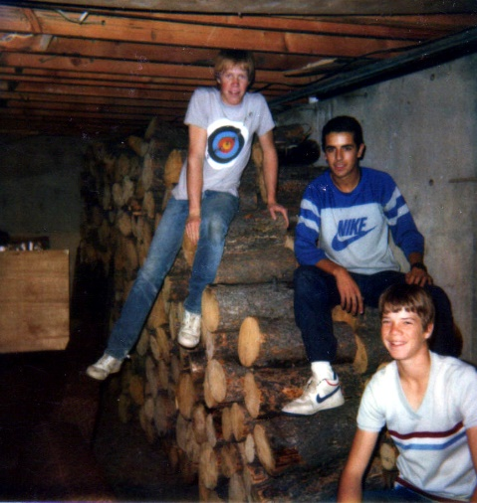

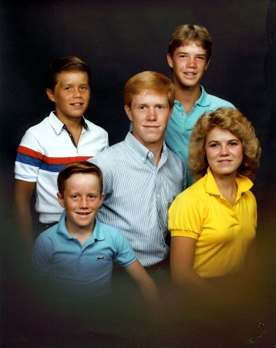We loved the home and 5 acres of land, the river close by and being out in the country. The boys loved it there - they were accepted right away. **Mike & David** became involved in sports – Football and Basketball, and made friends right away. Firth was a small town with a small high school, so they had lots of opportunities there. David was so friendly to everyone and everyone liked him because of that. Sometimes older kids look down on younger kids and think they are too good to speak to them, but David wasn’t this way, he was friendly with everyone. That is a great quality of David’s. Since Mike and David came from a farm and had experience in moving hand lines, the farmers up here wanted to hire them, so they got jobs in the summers easily. They each bought a motorcycle so they could ride to their jobs and back and then have fun riding in the river bottoms, etc. They did have lots of fun riding them, but I think they spent most of what they made on their jobs for parts to keep fixing their motorcycles. Mike’s friend from Grantsville came to stay a couple of weeks and he worked with them and had fun riding their motorcycles in the river bottom.

We had brought our cow, which we had in Grantsville, up to Firth with us. **Mike and David milked the cow,** but if they and their dad were gone on a Father-Son outing, **Shellie and I got the privilege of milking Bessie, when Ken and the boys were on scouting trips or father & son outings, and we were not very good at it. She was a patient cow, thank goodness because it took us a long time to milk her.** I got impatient with her, however, when she would get out and Ken wasn’t there and the children were in school and I had to go and chase her back into the corral. One time I remember, it was winter and we had lots of snow and Bessie got out. I saw her in the front yard. I got on my boots and winter coat and went out to get her. I would almost get to her and she would run the other way. I did this several times until I went into the house and asked Scott to help me. He had stayed home from school because he had the flu. I hated to have him go out in the cold, but I couldn’t do it by myself. Between the two of us, we finally got her back into the corral. Ken had her bred so we could raise a calf for beef and so we could continue to have milk from Bessie. He thought she had been bred, but it didn’t take and so we had to butcher her. She had already dried up and even if we had her bred again, it would be another 9 months without milk and we couldn’t afford to feed her all that time and not get any milk. I felt bad, however, as I had grown attached to her. I remember crying and talking to her the day they were coming to kill and butcher her.

We had a little **blue Dotson** and another bigger car for the family car, plus Ken had a truck for his construction business. We let Mike and David drive the Dotson. Mike was so particular and he would wash and clean the car until it looked so nice, but David wasn’t so particular and didn’t take care of it like Mike did, so they had some arguments about that. That was also the case when they shared a bedroom. Mike wanted the room kept clean and orderly and David could care less. Finally, I remember Mike drawing a line on the floor and he told David that he was not to throw anything on Mike’s side of the line, he had to keep his mess on his own side. In Firth, however, we had several bedrooms so they each had their own bedroom. I remember David asking me if I would help him clean his room. It would be a disaster. I asked him why he couldn’t clean his own bedroom and he would say “I don’t know where to start, I’m overwhelmed. If you will help me clean it, I’ll try to keep it clean.” So, I would and he would – for a while and after a while, he would come to me again with the same plea. I didn’t mind, I liked to help him and I was glad he did want it clean sometimes.

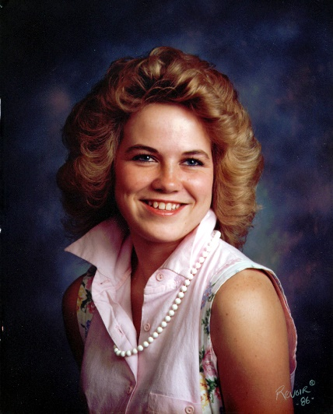**Shellie** was elected secretary of her senior class even though she was new at the school. She met Stacy Hobbs and they became best friends. Stacy was a cute blond with a bubbly personality. Shellie dated a nice boy named, Ralph. He really liked Shellie. She liked him some. Shellie loved to read and when I couldn’t find her, I would look in her room and she was either reading a good book, or putting a puzzle together. She loved putting puzzles together until her sister, Sandi, kept giving her harder and harder puzzles for her birthday or Christmas. Finally, she gave her one that was 1000 pieces and the puzzle was all black. That was it, she didn’t do puzzles after that. I was sad about that as she took after my mom in enjoying putting puzzles together. I was never good at that and didn’t have the patience for it. When I would go to Mom’s and find her putting one together, she would ask me to help her. She would put 10 pieces in to my one. Shellie did read good books and one day she was telling me about a book titled “One In Thy Hand” by Gerald Lund. She had read it and wanted me to read it. I told her I would like to, but I didn’t have the time – so she read it to me while I did other things. I did love it. It was about Jerusalem and the Jews and Arabs. From that point on, she had an intense desire to go to the Holy Land.

One incident I would like to insert was when **Ken and I were hosting a High Priest party at our home**. I had so much to do, so I asked Shellie if she would help me. She told me that she couldn’t because she had a date. I told her that he wasn’t picking her up for three hours and she told me it would take her that long to get ready. I practically begged her to help me as I didn’t know how I would get it all done without her help. She didn’t help, and I became really upset. I guess with getting upset, I worked harder and faster as the party turned out fine and everyone had a good time, but after they had all left, I sat down and wrote a long note to Shellie expressing how I felt. I told her of all the things I did for her, and that I couldn’t believe that she would be so selfish and inconsiderate as to not help me when I asked and really needed her help. She was still out on her date, so I left it on her bed. She acted cold to me the next morning and after she had gone to school, I looked in her room and she had torn the note up in hundreds of tiny pieces. I knew the note had upset her, but I felt she had it coming. A couple of years later when she was working at Max Inn and was asked to be the maid of honor at her friend, Stacy’s wedding reception, I drove up to pick her up and take her to the reception. We had plenty of time, so decided to drive on in to Yellowstone Park. As we were sitting admiring the beauty, we got talking and she told me how angry she had gotten when she came home from her date that night and read my note. She said she felt like running away from home. Thankfully, she didn’t. I expressed my love for her, but also how she made me feel. I was glad we could talk it out.

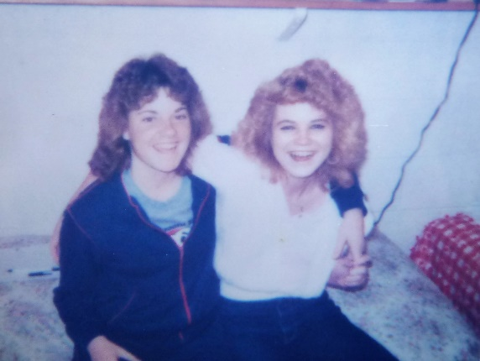**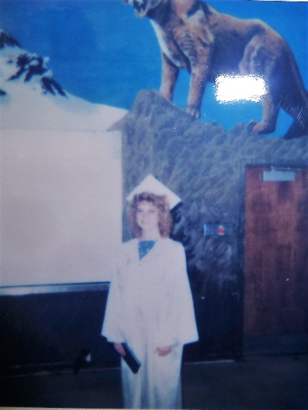Shellie graduated from Firth High and then went to BYU the following year.** It was even harder than I thought to have her leave. The last weeks before she left, I would find myself thinking that I wouldn’t be able to hear her playing the piano, playing her music on the stereo, seeing her reading good books in her room, having her around to help me and run errors, staying up late and having wonderful talks with her, etc., etc. I would find myself becoming sad and crying. After she left, it was the same thing. I had a hard time adjusting to having her gone. We had tried to talk her into going to Rick’s college or a smaller college for the first two years, but all she wanted was BYU. She did have a hard freshman year as they try to weed out all the weaker freshman they could because they have so many from all around the United States wanting to go there. She also had troubles with her room mates, and they put her in as activity chairman for their ward and she worked hard at it, but couldn’t get many to come, not even her **good friend, Becky Burgess, from Grantsville, who was her roommate.**  She had problems with Becky in more than one way while she was there. Shellie would come home at Thanksgiving and Christmas and cry and tell me how hard it was. I felt bad for her. She did stick it out and her Sophomore year was much, much better.

Another incident I would like to relate was when she came home from BYU for Thanksgiving and she mentioned that she would like to find a job, so that when school was out in December, she could work before and after Christmas. Stores always need extra people at this time of year, so I told her I would take her to Idaho Falls and she could put in her resumes. The Idaho roads are always so slippery, as it snows a lot and they don’t salt the roads to melt the snow after the snow plows go through. The roads were really slippery this day and it was snowing too. When we finally got there, I parked near a strip mall so she could go into several stores and fill out applications. Shellie looked at me and said she had decided that she didn’t want to go look for work today. I told her that we had driven on these bad roads and I had taken my time to bring her there, so she needed to go do it now. She just sat there, so I got out my book and started reading it. Finally, she got out of the car and went into the stores and got applications. **Shellie told me on the way home, that I was even more stubborn than she was, and when she saw me start to read my book, she knew I wouldn’t leave until she did what we came for.**

Shellie is a beautiful girl and so she dated quite a bit in high school and college. She has a strong testimony of the gospel; we called her our “straight arrow”. We could trust her and didn’t worry about her as she was very careful about whom she dated and where they went and what they did.

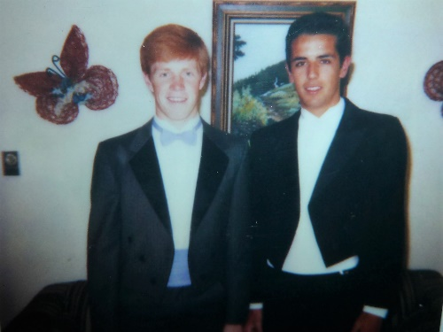**Mike** was going with a girl named Lisa. They were going steadily and Ken and I were a little worried. Mike’s best friends were Mike Mecham and Travis Dye. Mike was good at football and it was fun to watch him play. I didn’t understand all the rules of football, but I knew his number and would just strain to see and watch him. He did very well the first year, but at the first season game, of the 2nd year we were there, a boy on the other team ran into him or tripped him (I can’t remember) but Mike was down and they had to call 911 and take him off the field on a stretcher and to the hospital. That was an “away game” and about the only game we missed. We got a call that Mike was being taken to the hospital in Idaho Falls and we were to meet him there. They had to operate on his knee (scope it). Well, that was the end of his football season. He tried to play basketball after it healed, but it bothered him. He hasn’t been able to play many sports since then. **Mike and Bo double dated for their Junior Prom. They looked great in their tuxedos.**

**David** is a natural leader and very friendly so he had lots of friends. His best friend was Scott Adams. Scott wasn’t a member of the church, but a neat young man. His parents were great also. His dad was the principal of the elementary school. After we moved back to Utah and David was married, he found out that Scott had been killed in a plane accident. David, as well as us, were sad to hear that news. We had David’s 16th birthday party at our home in Firth. It was a surprise party. I always tried to have a surprise 16th birthday party, but not sure now how much they would have been surprised since I did that with each one. David & his friends played volleyball in the back yard and played on the trampoline. They played lots of game in the house, ate pizza and root beer floats, etc. They had a good time. Lots of girls and guys came.

**Scott** went to the elementary the first year and then to the middle school. Scott has always been a very good-looking boy so he has had girl friends since he was in kindergarten. Not that he liked girls that much, but because they liked him. One girl his age, **Danette**, was boy crazy in middle school, and started chasing Scott. She called him at home all the time. We got pretty annoyed with her. Many times, she would come down to our house to see him. At one of the basketball games, I pointed Danette out to Ken. Ken said “No”, that’s not Scott’s girlfriend, that must be David’s girlfriend. Danette was taller and very matured for a girl her age, so she looked more like 16 than twelve. I said “No”, that’s the girl who is chasing Scott and she is his age. That was one reason I was happy to move is to get Scott away from her. I don’t think he liked her that much, but I think he liked the attention.

When we were living in Idaho, Mike and David used to help Ken with building homes or doing remodeling, when he needed their help and one or the other was not busy. They were both busy one time when Ken needed some help with building a home, so he took Scott. Scott was only ten or eleven years old at that time**. Scott worked so hard and did such a good job that when they were eating their lunch, Ken told Scott that he was going to pay him as much as he paid Mike and David. When Scott acted surprised, Ken told him that he worked as hard and did such a good job that he deserved that much pay**. Ken said that when they went back to work, after eating their lunch, that Scott seemed to have even more energy and worked even harder.

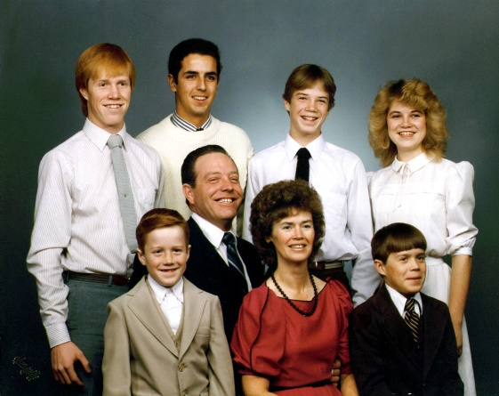 **Jeff** was in the 1st and 2nd grade in Firth. He was a shy little boy, but very sweet. He grew up with our dog, **Naunoo**, as Larry and Tammy gave us Naunoo when we were moving from Arizona to Grantsville. They felt Naunoo would do better and be happier on a farm where he could run and be free, rather than in a small yard in hot summers in Arizona. Jeff was only a year old when we got her, so they grew up together and Jeff loved Naunoo and Naunoo loved him as well as all the family. We all loved her. When we moved to Firth, we took Naunoo with us, of course, as we had five acres of land there for her to run in. But when we moved from Firth to Arizona, we left we needed to leave her there with the family who bought the home as she was too old and had arthritis and wouldn’t have done well in the hot summers in a small yard where we were going. It was a sad day for everyone when we left Naunoo and Penny (our other small dog), but especially for Jeff. I was sad for Jeff and it broke my heart when he hugged Naunoo and said goodbye to her with tears in his eyes.

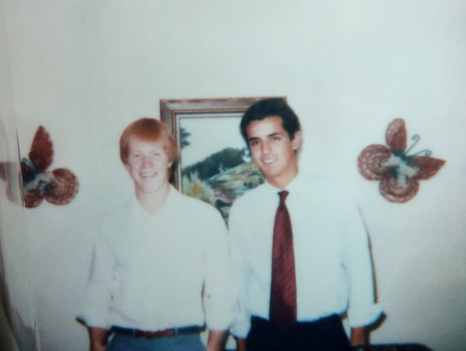I had a friend who was a case worker for **foreign exchange students**. She called me one day and said she had a young man from Spain who wanted to come over as an exchange student and immediately she thought of us. He was 16 and a junior in high school. She knew our son, Mike, was also 16 and she thought we would be the ideal family for **Borha. (We called him “Bo”** for short). I told her that we were not financially able to support a student at this time. She talked me into letting her come and show us his portfolio. We were impressed and Mike and David became really excited and tried to talk us into letting him come. My friend said that we didn’t have to worry about the money other than food as his parents were wealthy and he would have the money to buy all his clothes, pay for his school supplies, expenses, etc., etc. We talked it over as a family and decided to have him come. It was fun at the airport. We had a sign saying “Welcome Borha”. A Spanish looking boy got off the plane and came towards us. Mike thought it was him, even though his picture didn’t look like this boy, but we started walking off with him. He couldn’t speak much English, but soon after another man came up to us and this boy was coming to his family. We were embarrassed and ran back up to look for Borha. He was there looking for us. Bo was a tall, handsome young man. He was very polite (they are taught that in Spain). Bo brought me a beautiful Yadrow statue, which his mother sent for me. It was of a girl sitting on a log feeding a bird. Yadrows are very expensive. I have treasured it. It took us a while to be able to communicate well with Bo. He had had several years of English, but it is different learning it in a classroom and speaking it to Americans. However, it didn’t take him very long until we could understand each other. While we were in the process, Mike said to me “Mom, you don’t need to shout! Bo isn’t deaf.” I would find myself talking slow, but also loud. The family took to Bo and he liked us. Even though he wasn’t a member of our church, he would go to church with us. He always opened the door for me, if Ken wasn’t around to do it, and he insisted on carrying my books until some of the men made fun of him for doing it. That upset me. I heard him talking to a friend, on the phone who came with him and was staying with a family in Shelly Idaho, saying Americans are not polite and most don’t want us to be polite, so maybe we shouldn’t do it any more while we’re here. I felt bad as I knew their mothers had taught them well. I had a Polaroid camera so I took lots of pictures and I made a scrapbook for Bo and each of the children. I wanted Bo to have the book to remember us by. He was excited. Bo was very athletic and very smart. He got straight A’s in school, and once we taught him a game – tennis, ping pong, board or card games, etc., he was good at him**.**

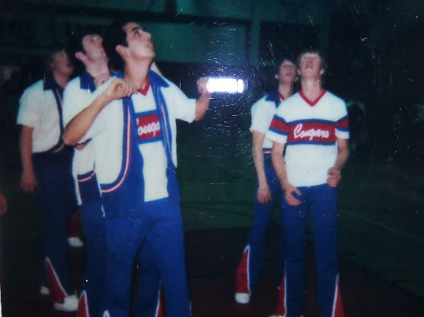**Bo and Mike tried out for the basketball team, and both made the varsity team.** David played on the Sophomore basketball team, but the coach played mainly the younger boys – Freshman, even though David and some of the other Sophomores were better – at least we thought so. The coach wanted to build a great team for the following year we think so he let the sophomores sit on the bench. The coach was also a seminary teacher, so we were surprised that he would do that. Guess we’re all human. Mike played on the varsity football team also. David played church basketball after that and was really good. We really enjoyed watching those games more than the school basketball games. The varsity coach was a loud mouth, swearing, harsh coach and not many liked him, including Mike and Bo.

**We enjoyed living close to Irven and Sandy**, although at times we would get upset with Irven as he was a salesman in about every way – a high pressured salesman. He would try to pressure us into doing things, but Ken isn’t one to be pressured so they would go the rounds. Irven is a good guy though. We got together fairly often to play games and that was always fun. We would eat at each other’s homes different times too. Sandy and I enjoyed each other; we felt more like sisters than sisters-in-law. Sometimes we would get to laughing and laugh so hard we could hardly stop. One time we decided to sell Fuller Brush Products together to earn some extra money for our families. She had a man in their ward who was a supervisor in it, so we set out together. We would come to our area and she would go to one side of the street and I would go on the other side. We had fun doing this, but didn’t make much money. We would stop and get ice cream cones after sometimes. Sandy was always looking for ways to make money so a couple of months before Christmas she told me about her idea to make a Christmas book with all kinds of Christmas activities and ideas in and we would advertise and sell them. We spent a lot of time making them. They were pretty good ideas, but I don’t think we sold hardly any. Oh well, we had fun doing them together. I think we made enough to pay for our expenses – hope so anyway.

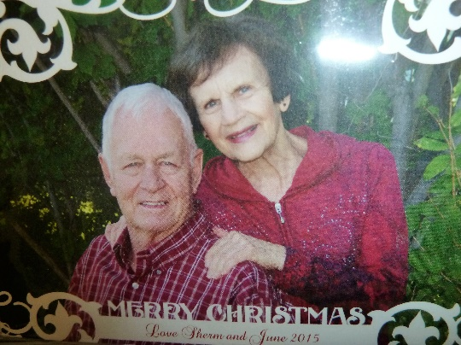

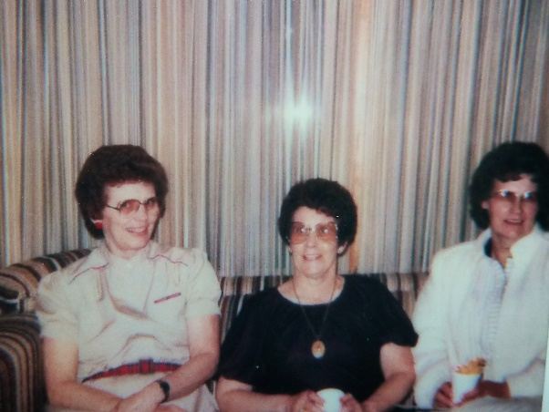I had several good friends in Firth – **June Mecham** was a very sweet beautiful lady and I loved her. We still keep in touch especially at Christmas. Her husband was Sherm and he was a coach & school teacher. They came to visit us when we were living in Clinton, I fixed lunch for us and we had a good visit. June was the mother of Mike’s best friend who name was also “Mike” – Mike Mecham.

**Doris Gentillan** was a special friend too, we had lots of good talks and did things together. Doris had two married daughters who lived in the ward. They were cute girls with cute families. (Doris is the lady on the left in the picture.)

**Kurt and his wife Karla** **Tew** had a son, Cody, a year or two younger than Jeff and they played together and had fun. Kurt and Karla were good to Jeff, and actually to all our kids and to us. They were great neighbors. I think all of us hated to leave Firth. Darlene and her husband (can’t think of his name) lost their lumber business in Firth, and later lost their home. The bank called us since we were renting their home and offered to let us buy it for $35,000. with low interest. Wow! What a great deal that was, but that was the time when many potato farmers (and that was mainly what the people in Firth and surrounding area, did for a living.) went bankrupt and the ones who didn’t couldn’t hire Ken to build a new home or do remodeling like they had planned, so Ken had no work and thus no money to buy this home. We were sad about this, but that is when we moved to Arizona to go into partnership with Larry Braithwaite and Ron Shumway in construction. Ken had called Larry to see if there was work in Arizona as he had no work here in Idaho. He had called other contractors to see if he could work for them, but they had no work either. Larry told him “yes” and to come down. He stayed with them and worked for Larry and Larry was trying to talk him into going into business with him again. I didn’t know at the time, but Ken really didn’t want to. He just wanted to work there until he hoped things would go better in Idaho and he could come back and we wouldn’t have to move again. I guess we didn’t communicate well enough because I didn’t understand that and since we couldn’t buy the home, and since there was no work here, I figured we would have to move to Arizona again since there was work there. Larry called me and convinced me that Ken should go into business with him and told me to talk Ken into doing so. I did, but wish we had communicated better. Don’t know if it would have made a difference or not, but this move was not good for any of us except Shellie as this is when she met him. Actually, I liked it there as Larry & Tammy had helped us buy a home (they talked us into getting a nice one and helped with the down payment I think). I loved the home. We had lots of good times with Larry & Tammy until towards the end. We went water skiing, to their cabin, family dinners together or at the park, etc. I had met many good neighbors and made friends in the ward and I was in the R.S. Presidency.

We, of course, had brought **Naunoo and Penny** with us to Firth. They loved it there too and so did we. I would sit on the front steps of the house and Naunoo would come by me and put her head under my arm so I would pet her. She was so cute. We lived in Grantsville for four years and only two years in Firth, when we moved to Arizona the third and last time. Penny had been run over by a car as she had gotten up on the highway and we were sad about that. **We couldn’t take Naunoo with us to Arizona** as it would again be too hot for her there and we would be living in a sub division and it would be too confined for her, so we asked the people who bought the home if they would keep her and they were glad to have her. The day that we left, we were all sad to leave her. I still remember the picture in my mind of Jeff kneeling down by Naunoo with his arms around her neck and he was crying, it still makes me sad to think of it.

**1985 – Christmas letter**

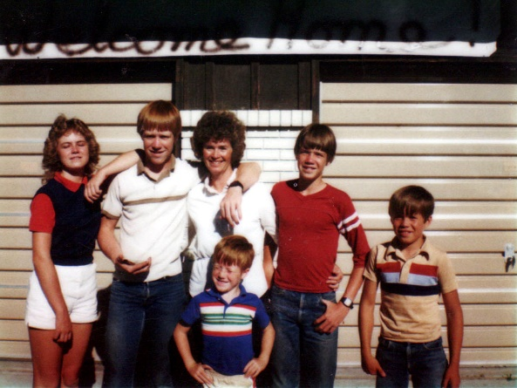We have three boys in basketball this year, and they each play one to three games a week, and since they are all on different teams, we are going to be at the High School watching a lot of games for the next two or three months. You might wonder how we have three boys playing; its because we have a foreign exchange student this year from Spain. He’s 16 and his name is Borja Sanchez-Blanco. He is very good at basketball since he played a lot in Spain so he is playing on the Varsity team, Mike is playing Junior Varsity, and David is playing on the C Team.

Borja is tall, dark, and handsome, intelligent, good at about everything he does, very polite, helpful, and friendly. We are really enjoying him, and learning a lot about the beautiful country of Spain.

We had moved to Firth, Idaho the summer of 1984, this is a beautiful, friendly place to live and a good place to raise children. But it sure gets cold in the winter, and we have lots and lots of snow. Oh well, I guess there’s not a perfect place to live. We do enjoy it here, and the children have good friends and really enjoy living here in Firth.

Ken is a contractor, and has been really busy this past summer. We hope it continues. He is a good builder so he hasn’t had to advertise, he has gotten work through word of mouth. He keeps really busy, and teaches the Deacons in the Aaronic Priesthood.

I’m in the Primary Presidency and involved in School and Community. My family sure keeps me going too. This is really a busy life.

Shellie is going to the Brigham Young University. It was a little overwhelming for her to go there after coming from small schools like Grantsville High and Firth High. She is doing good, but is looking forward to the Christmas Semester break with three whole weeks without homework. She is a special girl and we are very proud of her.

Mike is 16 and a junior in High School. He is involved in all sports; in fact, he injured his knee during football season, and is recovering from an operation on it. He is upset that he has to miss the first few games in basketball because of it. David is 15 and in the 10th grade. He also is involved in sports. Both boys get good grades. They are both involved in church. Mike is the Priest quorum assistant, and David is the president of the Teacher’s Quorum. Mike is also on the Seminary Council. Scott is in the 6th grade, and Jeff is in the second. We are a family with all boys now that Sandi is married and Shellie is away at college. Sandi has two daughters and we sure enjoy them, but we don’t see them as often as we’d like since they live in Grantsville.

We enjoy this time of year, but wish it wasn’t quite so busy. I’m over the Ward Christmas party, and we also are having a party for our teachers and their spouses in Primary next week.